PROFESSIONAL TRAINING REPORT
at
Sathyabama Institute of Science and Technology (Deemed to be University)

Submitted in partial fulfillment of the requirements for the award of Bachelor of Engineering Degree in Computer Science and Engineering
By

SONISH.S (Reg.No.37110729)



DEPARTMENT OF COMPUTER SCIENCE AND ENGINEERING SCHOOL OF COMPUTING
SATHYABAMA INSTITUTE OF SCIENCE AND TECHNOLOGY JEPPIAAR NAGAR, RAJIV GANDHI SALAI,
CHENNAI – 600119, TAMILNADU

AUGUST 2020



SATHYABAMA
INSTITUTE OF SCIENCE AND TECHNOLOGY

(DEEMED TO BE UNIVERSITY)
Accredited with Grade “A” by NAAC
(Established under Section 3 of UGC Act, 1956)
JEPPIAAR NAGAR, RAJIV GANDHI SALAI, CHENNAI– 600119
www.sathyabamauniversity.ac.in

DEPARTMENT OF COMPUTER SCIENCE AND ENGINEERING

BONAFIDE CERTIFICATE

This is to certify that this Project Report is the bonafide work of SONISH.S (37110729) who carried out the project entitled “GAME DEVELOPMENT USING PYGAME” under my supervision from April 2020 to June 2020.

Internal Guide
Ms.T.ANANDHI

Head of the Department

Dr. S. VIGNESHWARI, M.E., Ph.D.,

Submitted for Viva voce Examination held on

Internal Examiner External Examiner
DECLARATION

I SONISH.S (Reg. No. 37110729) hereby declare that the Project Report entitled “GAME DEVELOPMENT USING PYGAME” done by me under the guidance of MS.T.ANANDHI is submitted in partial fulfillment of the requirements for the award of Bachelor of Engineering degree in Computer Science and Engineering.

DATE:

PLACE: SIGNATURE OF THE CANDIDATE
ACKNOWLEDGEMENT

I am pleased to acknowledge my sincere thanks to Board of Management of SATHYABAMA for their kind encouragement in doing this project and for completing it successfully. I am grateful to them.
I convey my thanks to Dr. T.Sasikala M.E., Ph.D., Dean, School of Computing , Dr.S.Vigneshwari M.E., Ph.D., and Dr.L.Lakshmanan M.E., Ph.D., Heads of the Department of Computer Science and Engineering for providing me necessary support and details at the right time during the progressive reviews.
I would like to express my sincere and deep sense of gratitude to my Project Guide Ms.T.Anandhi for her valuable guidance, suggestions and constant encouragement paved way for the successful completion of my project work.
I wish to express my thanks to all Teaching and Non-teaching staff members of the Department of Computer Science and Engineering who were helpful in many ways for the completion of the project.
TRAINING CERTIFICATE

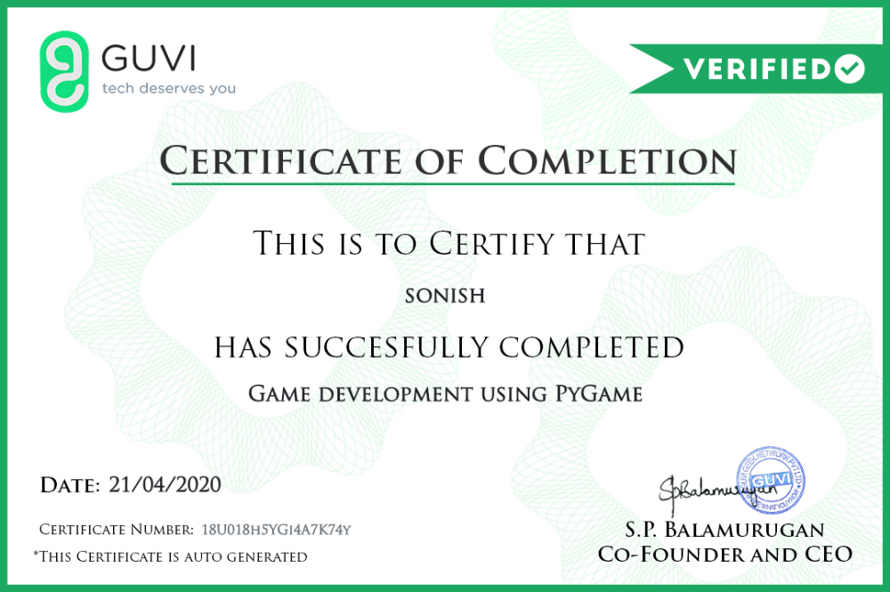

ABSTARCT

The growth of the software game development industry is enormous and is gaining importance day by day. This growth imposes severe pressure and a number of issues and challenges on the game de- velopment community. Game development is a complex process, and one important game development choice is to consider the developer perspective to produce good-quality software games by improving the game development process. The objective of this study is to provide a better understanding of the devel- oper’s dimension as a factor in software game success. It focusses mainly on an empirical investigation of the effect of key developer factors on the software game development process and eventually on the qual- ity of the resulting game. A quantitative survey was developed and conducted to identify key developer factors for an enhanced game development process. For this study, the developed survey was used to test the research model and hypotheses. The results provide evidence that game development organizations must deal with multiple key factors to remain competitive and to handle high pressure in the software game industry. The main contribution of this paper is to investigate empirically the influence of key de- veloper factors on the game development process.
 | TABLE OF CONTENTS
CHAPTER No. | TITLE | PAGE No
 | ABSTRACT | vi
 | LIST OF FIGURES | ix
1 | INTRODUCTION | 1
 | 1.1 INTRODUCTION  1.2 AIM  1.3 SCOPE | 1  2  3
2. | LITERATURE REVIEW | 4
 | 2.1 LITERATURE REVIEW | 4

3. DESIGN IMPLEMENTATION AND BLOCK DIAGRAM 11

 | 3.1 DEVELOPMEN CYCLE | 11
 | 3.2 SPECIFICTAION | 12
 | 3.3. BACKGROUND RESEARCH  3.4 CODING  3.5 TESTING  3.5.1 SYSTEM TEST  3.5.2 USEABILITY TEST  3.5.3 BETA TEST  3.6 IMPLEMENTATION | 13  18  19  20  21  21  24
4. | RESULTS,METHODOLOGY AND DESIGN | 25
 | 4.1 DESIGN | 25
 | 4.2 RESULTS  4.3 METHODOLOGY | 30  30
5 | SOFTWARE REQUIREMENTS  5.1 JUSTIFICATION OF TOOLS | 33  33
6 | CONCLUSION AND FUTURE SCOPE  6.1 CONCLUSION  6.2 FUTURE SCOPE  APPENDIX | 36  36  37  39
 | A.SCREENSHOTS | 39
 | B. SOURCE CODE  REFERENCES | 44  51

LIST OF FIGURES

FIGURENO. FIGURENAME PAGENO.

3.1 WATERFALL MODEL 12

3.2 BIG BRAIN DIAGRAM 14

3.3 CIVILIZATION 15

3.4 MINECRAFT 16

3.5 SIMCITY 17

3.6 QUIZ TABLE 22

3.7 MINECRAFT 23

4.1 INITIAL DIAGRAM 25

4.2 FINAL DIAGRAM 27

4.3 MODEL STUDY 28

CHAPTER 1
INTRODUCTION,AIM AND SCOPE

1.1 INTRODUCTION
Educational video games have been used for several decades. Some of the earliest educational video games, such as The Oregon Trail (1971), were stimulating and got players learning. However, in recent years educational video games have not been effective, as players have felt like they were learning instead of playing a video game.
This report presents the video game development cycle from the requirements specification stage to the implementation stage. The video game was designed to answer the academic question. Whilst creating the video game, the following criteria were considered and answered:
- Selecting appropriate software to develop the video game.
- Choosing suitable educational principles to be implemented in the video game.
- Ensuring the video game was suitable for primary school children.
Game design is the art of applying design and aesthetics to create a game for entertainment or for educational, exercise, or experimental purposes. Increasingly, elements and principles of game design are also applied to other interactions, in the form of gamification.
Academically, game design is part of game studies, while game theory studies strategic decision making (primarily in non-game situations). Games have historically inspired seminal research in the fields of probability, artificial intelligence, economics, and optimization theory. Applying game design to itself is a current research topic in metadesign.
The report starts with the literature review where the fundamentals of educational video games were discussed. This includes how video games are currently being used by educational institutions and how they cover different learner styles. The report then continues on to the development cycle, where the video game was developed. After the development of the video game, it was tested by twenty final-year university students. The results from these tests were then used to answer the academic question. The report concludes with how it met all the aims and objectives of the project and a critical evaluation of the methods and tools used to develop the video game.

The topic area for this project is educational video games. This project will interest its stakeholders, which are educators and game developers. The project will interest educators as it provides data which shows video games can be used to teach educational principles. Working with game developers, educators will be able to learn a suitable method for implementing their educational content into video games. Game developers will find this project interesting as it provides a suitable game development process for the creation of educational video games.

1.2 AIM
- To evaluate the use of video games as educational tools.
- Investigate educational video games.
- Evaluate the video game development process.
- Develop knowledge in a scripting language.
These aims were then broken down into several objectives which were:
- Complete a literature survey and literature review on how video games are being used as educational tools.
- Identify and evaluate game design of existing educational video games.
- Develop a suitable video game.
- Evaluate the effectiveness of the video game using appropriate tests.
- Identify video game development approaches suitable for modelling educational video games.
- To learn and develop skills in a scripting language dependent on the tools used to develop the video game.
- Complete final report.

1.3 SCOPE
The game development industry is known to pay well and is one of the many illustrious professions in the world. Though the salary of a game development professional varies depending on the organisation, we have come up with an estimates
The most common myth about game industry jobs is the lack of options. However, game careers are not limited to game design and game development. Here are some game industry jobs that you can take up as a profession:
Financial motivation can drive you ahead in life! The game development industry is known to pay well and is one of the many illustrious professions in the world. Though the salary of a game development professional varies depending on the organisation, we have come up with an estimate. So, before you step into the gaming world, here’s an overview of what your bank balance will look like.
A video game designer and an audio programmer are most likely to not have the same set of skills that are instrumental in a game. However, their worth in the market, in terms of average salary, is estimated to be around £30,000 per annum. A video game artist’s average salary is around £40,000 per annum, while that of a game producer varies from £40,000 to £80,000 depending on the success of the game. A writer’s average income also depends on the game’s success and can go up to £150,000!

CHAPTER 2

LITERATURE REVIEW

2.1 LITERATURE REVIEW
Nalin Sharda (no date) states educational video games are systems that use digital technology to create games for enhancing learning outcomes and have been recognized as pedagogical tools which are engaging and effective. This indicates that educational video games are a viable method to teach students about educational principles. Mark Griffiths (2002) expands upon Nalin Sharda’s views by revealing that for several decades, video games have been used as educational tools as students. This was because students prefer this type of approach to teaching. This signifies that students prefer this method of teaching instead of the older method. According to Mark Prensky (2001), the reason that students prefer this method over the older method is because:
“Educators teach in an outdated language (that of the pre-digital age) and are now struggling to teach students that speak an entirely new language (which is post digital-age). This is because today’s students have grown up around technology, which has resulted in them to find the current method and pace of teaching too slow.”
This signifies that the current education system is not designed to teach today’s students. This leads to students being demotivated and bored while at school, which means they will not be learning. Katie McClarty et al. (2012) declares that by continuing to provide this type of education as the world continues to evolve will not serve the students well. This is because students are not learning because they are not motivated to do so. This will lead to them not achieving necessary skills for the future. James Gee (2004) stated that video games are an excellent educational tool where students can exercise their learning muscles without knowing it and having to pay overt attention to the matter. This means that students who tend to be bored or demotivated by the current teaching method can learn by using video games. Video games can provide real life examples where students will see a legitimate use for the educational concepts (Katie Ash, 2011). This means students will be motivated to continue to learn as they will be able to see real life scenarios where they can apply the educational principles they have learned. Mark Griffiths (2002) expands upon James Gee points by stating that in addition to students, teachers tend to find video games useful as it allows them to measure student’s performance on a very wide variety of tasks. This conveys as video games can be used to teach several different educational concepts simultaneously. However, Mary Jo Dondlinger (2007) expresses that not all video games can be used as educational tools. For the video game to be an effective educational tool, it will have to motivate students and have educational principles implemented effectively. This indicates that for video games to be considered as educational tools, it should motivate them to continue playing whilst teaching them new educational principles. If the video game does not teach students, they will be just getting entertained. This means that the video game they are playing is an edutainment video game, not an educational video game. Edutainment games are different compared to educational video games as Denis Guillaume and Pierre Jouvelot (2005) state that the main characteristic that differentiates them is interactivity. This conveys that where edutainment games tend to just entertain students, educational video games will entertain students as well as teach them. Denis Guillaume and Pierre Jouvelot (2005) continue by stating that this leads to edutainment games often failing in transmitting non trivial knowledge, as their main purpose is to entertain whilst educational video games main purpose is to educate. However, not all video games are edutainment or educational games. This leads to newspapers tending to blame them for health and mental issues. Rob Preece (2012) said in his article that playing video games puts teenagers at greater risk of getting diabetes. Because of statements made in articles like this, educational institutions are reluctant to use video games as educational tools. Nonetheless, research has shown that the negative consequence of playing video games almost always involves people who were excessive users. Mark Griffiths (2002) asserts that when video games are designed to teach a certain skill, they have a great positive potential in addition to their entertainment value. This indicates that educational video games can be beneficial if designed correctly. This can lead to students learning new educational principles.

A significant characteristic found in video games is motivation. According to Mary Jo Dondlinger (2007), the reason for this is that when students are motivated to play, they will not feel like they are learning. This signifies that if the educational video game is interesting, students tend to be more motivated to continue playing and learning. There are however two types of motivation, which are extrinsic motivation and intrinsic motivation. Jacob Habgood and Shaaron Ainsworth (2011) disclose that traditionally, educational video games attempted to harness video games as extrinsic motivation by using them as sugar coating for learning content. This indicates that educators used video games as the motivation for students to learn. This has been proven ineffective as students stated that they were aware that they were learning, which led to them not enjoy playing the video games. This signifies that for educational video games to be effective, they will have to provide intrinsic motivation instead of extrinsic motivation. Intrinsic motivation comes from the individual and not from any apparent rewards (Siegwart Lindenberg, 2001). This means that if the student enjoys the content of the video game, they will be motivated to continue playing. This is not because they are playing a video game but because they are enjoying the content of the video game. According to Richard Ryan and Edward Deci (2000), this can result in high-quality learning and creativity. This is because players will be motivated to learn by themselves, and not be forced to do it. Denis Guillaume and Pierre Jouvelot (2005) claim “As most video games deal with fun, they are a potent source of intrinsic motivation.” This expands on earlier points by stating that intrinsic motivation comes from doing something that the player is enjoying. This means to ensure that an educational video game is effective; it will need to provide intrinsic motivation to whoever is playing it. One way to guarantee this is to ensure that the goals of the video game and the learning content are closely tied together; this will mean the rewards for the players will be in solving challenges and learning (Mary Jo Dondlinger, 2007; Katie McClarty et al., 2012). This indicates that if the goal of the game is to win by learning, they will be motivated to learn. Mary Jo Dondlinger (2007) expands on what makes an effective educational video game by stating:
“Characteristics that educational games should have to motivate students include a system of rewards and goals, a narrative context which situates activity and establishes rules of engagement, and interactive cues that prompt learning and provide feedback.”
This means that for an educational video game to be effective, it should have all these characteristics. Having these characteristics will lead to players being intrinsically motivated to continue playing. However, Pablo Moreno-Ger et al. (2008) expands upon Mary Jo Dondlinger’s views by declaring that there is no all-purpose solution to the design of educational games. This signifies that there is not a set guideline for developing educational video game which means that every educational video game will be different to create.

The most difficult aspect of creating the video game will be implementing the educational content effectively into the video game. This is because the educational content has to complement the video game so that players will be intrinsically motivated. Jacob Habgood and Shaaron Ainsworth (2011) expand upon this view by mentioning “When the educational content is closely linked to the narrative plot it will lead to an intrinsic motivated game. Then the enjoyment of the game will derive from the process of learning itself.” This signifies the importance of the educational content being linked to the narrative plotline to ensure that the video game is intrinsically motivating. Studies have shown that effective educational video games have their learning content closely related with the narrative plotline (Mary Jo Dondlinger, 2007). This expands on earlier views by indicating that if the educational content is not well implemented, it can lead to the educational video game not being effective. This can make the difference between a video game being an effective educational tool or just another edutainment game. According to Glenda Gunter et al. (no date), edutainment games are not effective as they will lead to students being entertained by the video game but not acquiring new skills or knowledge. This statement goes with the status quo that for the educational video game to teach educational principles, the educational content should be closely related to the game’s narrative plotline. David Harlow (2004) signifies the importance of making a player wish to learn but also ensuring that the video game is enjoyable and fun, and not just an interactive textbook. David states the best method to do this is by providing continues challenges to players, which they should solve with the knowledge they gain from the video game. This implies that the educational content should be closely related to the video game, most importantly the plotline and its challenges, for it to be effective.

In recent years, educational video games have not been effective. David Harlow (2004) signifies the main reason for this is due to the majority of them having been poorly designed, and having resembled nothing more than overdeveloped interactive textbooks. This implies that for educational video games to be effective, they should first be well designed. This is usually done by following a design methodology. The first step in the design methodology is the concept, which is a list of features and educational content to implement in an educational video game. This is to ensure that the educational content is related to the game’s narrative. The next step in the design methodology is to choose an appropriate genre for a video game. However, there is no appropriate genre for educational video games. This is because all students have a different favorite genre which they enjoy playing video games in. Raph Koster (2005 pp. 104-105) claims the reason for this is that “different brains have different strengths and weaknesses, so different people will have different ideal games.” This implies that every player has their own favorite genre suited to their strengths and weaknesses. Mary Jo Dondlinger (2007) expands upon Raph Koster’s views by suggesting:
“To overcome this problem, the best genre to choose to make an educational game will be RPG (Role Playing Games). RPG contains elements of various different genres, specifically of adventure and strategy games. This is important as studies have shown that adventure and strategy games were found to be the most stimulating and rated the highest.”
This indicates the most suitable genre for educational video games will be RPG as it contains aspects of other genres. This could lead to players enjoying the video game as it will contain features of their favorite genre. After choosing a game genre, the next step in the design methodology is usually to create and implement the game rules. Katie Salen and Eric Zimmerman (2004 pp. 118-125) stated that rules are one of the essential qualities of a video game as they define it and provide a formal structure. This indicates that the rules will create the basic structure of a video game. The rules will usually indicate how players will play a video game. Raph Koster (2005 p. 120) suggests the next step in a video game design methodology is to create the challenges as “they are a part of the game content, therefore they will not change the game rules but will allow for a different set of parameters.” This means that the challenges in a video game will expand upon the rules, not change them. To ensure that an educational video game is effective, the challenges should complement the educational content. James Paul Gee (2004) suggests that “The challenges created in the game should be pleasantly frustrating in the sense of being felt by learners to be at the outer edge of, but within their regime of competence.” This implies that challenges created in an educational video game should be difficult for the players but still be manageable to do. Katie Salen and Eric Zimmerman (2004 pp. 328-361) reaffirm the views of Jacob Habgood and Shaaron Ainsworth by stating that the challenges should be integrated with the rules of the video game to create a larger fabric of game experience, which is important to sustain player pleasure. Raph Koster (2005 p. 122) maintains the importance of letting players know when they complete challenges. To implement this in a video game, Raph suggests using a variable feedback system. This means implementing a reward for system where players are rewarded for completing challenges. Players should be given greater rewards for harder challenges. This will indicate to players that they have completed a challenge and can go to the next aspect of a video game. The last aspect of a design methodology is the actual design of the video game. Andrew Rollings and Dave Morris (2004 p. 50) claim that the level design of a game is a significant part of the core gameplay as good level design will contribute greatly to the style and storyline of the video game. This means to for an effective educational video game, the design should be linked with the game’s plotline and the educational content. This can create an effective educational video game where players will not only learn, but also enjoy playing.

Every player has a different learning style, whether they are a child or an adult. There is no research indicating that there is one learning style suited for all children in a certain age group. This indicates that for an effective educational video game, it should have aspects of all different learning styles. To ensure this a learning model should be used. Walter Leite et al. (2010) suggest using Neil Fleming’s VARK model as it is the most popular and most commonly used model. The VARK model covers three distinct learning styles, which are visual, aural and kinesthetic. Visual learners are individuals who learn by seeing images. An effective educational video game for visual learners would use images, and not be just text based. Aural learners are individuals who enjoy learning by sound. An effective educational video game for aural learners would use sound to indicate clues. This will ensure that individuals with these learning styles will enjoy the video game. Kinesthetic learners are individuals who learn by doing. An effective educational video game for kinesthetic learners would be interactive to ensure that individuals can learn from playing the game. Nalin Sharda (no date) claims that learning outcomes depend upon the match between learning styles and those offered by the system. This means that if the learning styles offered by an educational video game are similar to its players, they will learn more compared to an educational video game that does not offer the players learning style. However, research conducted by Harold Pashler et al. (2008) contradicts the views of Nalin Sharda and indicates that users will not learn best when they are taught in their preferred learning style. Research conducted by Peter Fenrich (no date) expands upon both Nalin Sharda and Harold Pashler views where it states that
“A match between learning style and instructional design can result in increased achievement as well as better attitudes. However, when a learner’s preferred learning style does not match the instructional design, effective learning can still occur.”
This indicates that even if educational video games do not cover all distinct learning styles equally, it will not mean that players of that learning style will learn less. To ensure that every learning style is motivated to keep playing, Peter Fenrich (no date) suggests providing varied activities so that each learner is likely to have a preferred activity for a reasonable amount of time. This signifies that challenges in an educational video game should have an equal amount of visual, aural and kinesthetic activities so that all distinct learning styles will be motivated to keep playing.

CHAPTER 3

SYSTEM IMPLEMENTATION AND BLOCK DIAGRAM

3.1 DEVELOPMENT CYCLE
The development cycle that was chosen for the artefact development was Winston Royce’s waterfall model. The waterfall model is where the development is broken down into different stages. Once a stage is completed, the user goes on to the next stage. The waterfall model allows going back to a previous stage, which is known as splashing back. This model was found the most suitable for the artefact development as uncertainty and complexity were both low for the user interface design and user requirements. This was because the requirements of the artefact were clearly understood at the beginning of the development stage. There was a high risk for the artefact in terms of schedule but the waterfall model is a structured approach that allowed for easy time management.

An alternative development cycle that was considered for the artefact was rapid prototyping, also known as evolutionary prototyping model. Rapid prototyping is an unstructured approach in which the core artefact is produced. It is then built upon that every time during the development cycle. Rapid prototyping was found not suitable as there was limited time for development. Rapid prototyping requires time so that a prototype can be shown to a client and then continue build upon with any changes recommended by the client. Rapid prototyping is most suitable when there are uncertainties in the user requirements. The requirements for the artefact were clear at the beginning of the development hence the rapid prototyping development cycle was found not suitable.

The waterfall model which will be used in the development of the artefact can be seen in figure 3.1.

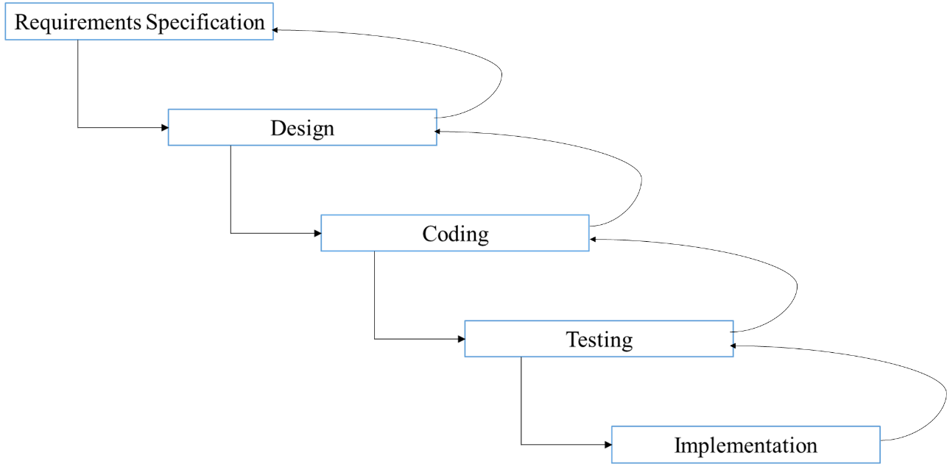
Fig 3.1 (Waterfall model)

There are five different stages to the waterfall model which all serve a different purpose towards the development of the artefact. The stages were requirements specification, design, coding, testing and implementation.

3.2 SPECIFICATION
The requirements specification stage was where the artefact’s requirements were stated and what it intended to achieve. The first requirement of the artefact was to answer the academic question, which was to see if video games can be used teach basic educational principles to primary school children without them being aware that they are learning. To use the artefact effectively to answer the academic question, it was going to be designed as a video game. Gary Geisler et al. (2008) stated that video games are sophisticated applications, which are graphic-intensive and contain immersive experiences. This meant that the video game that was going to be created had to contain graphics and create immersive experiences for its primary user. To ensure that the artefact was a video game it was designed first in the design section in 3.3. This included background research on previous and current educational video games. As the video game had to teach basic educational principles to primary school children, research was also undertaken on what primary school children are learning during the ages of 7 – 11. This was also a part of the design section.

Another requirement for the video game was to aid in achieving the aim of developing knowledge in a scripting language. The aim is linked to the objective of developing skills in a scripting language dependent on the tools used. A scripting language is a high level programming language used to create programs or scripts. Some examples of scripting language are C++, Java, Python and Ruby. To achieve this requirement, the video game creation tool had to involve a scripting language. Background research was conducted into tools used to develop video games. This would ensure that the tool included an opportunity in developing skills in a scripting language. This research was done in the justification of tools section, which is in 3.3.1.

The video game also had the requirement of achieving the objective of creating a suitable video game. This meant that the video game’s content had to teach its primary user, which were primary school children. This requirement was linked very much to the first requirement, which was to answer the academic question. This was due to both requirements needing a suitable video game which had educational principles build in. For the video game to teach effectively, it had learning outcomes. The learning outcomes were stated in the design section.

3.3 BACKGROUND RESEARCH
Background research was conducted on modern video games. The research consisted of evaluating four modern video games on how they taught educational principles effectively. The finding of this research was then used to design the video game for this project.
1.Big Brain Academy: Wii Degree (2007)
Big Brain Academy is an educational video game designed to teach children and adults via mini games.
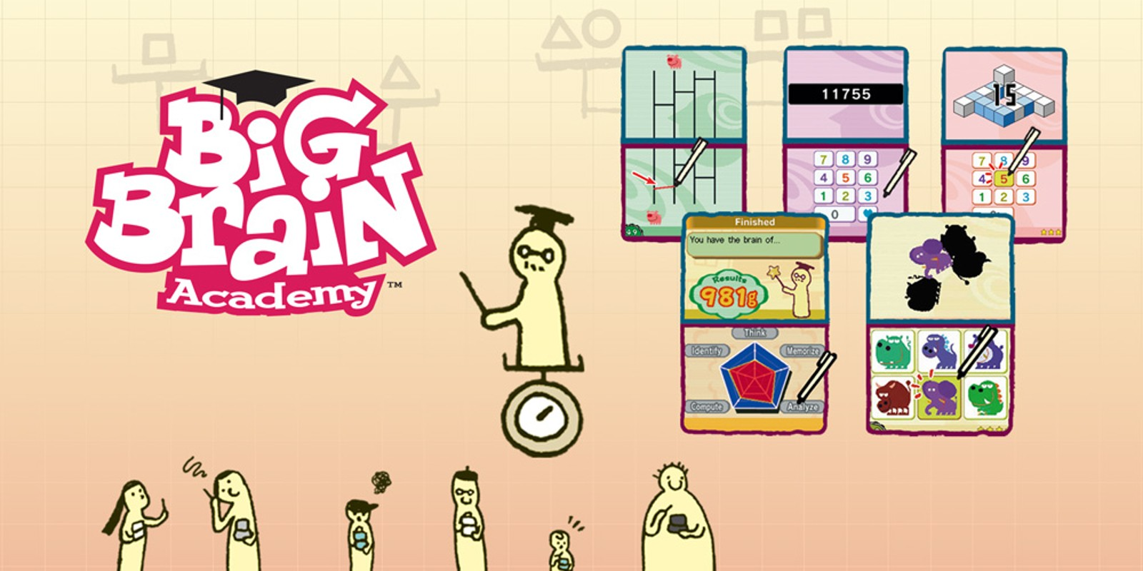
Fig 3.2(BBA)
The educational content in this video game was about logic, mathematics, spatial reasoning and geometry. The educational content was taught by users playing different mini-games. The goal of Big Brain Academy was for users to answer as many questions correctly in mini-games. This ensured that all the educational content was covered in one sitting of the video game. After completing the mini-games, user’s scores were added up and they were shown in the format of the weight of the user’s brain. The more questions correctly a user got, the heavier their brain would be.

Big Brain Academy taught its educational content effectively as users would play the mini-games repeatedly to achieve a higher score. This made the user more motivated to continue playing. This ensured that users did not latch on that they were learning but just playing a video game. Users enjoyed playing the mini-games as they were short. This meant that they did not have to dedicate long periods of their time just to play the video game. Big Brain Academy also supported multiplayer, where users could compete against other players to achieve the highest score. This allowed Big Brain Academy to teach several users at the same time, without any of them being aware that they were learning.
2.Civilization v (2010)
Civilization V is a strategy video game where users would build their own civilization from prehistory to the future. Although the video game was not designed to be educational, it was found to be beneficial as a learning aid to teach about history, culture and economics.
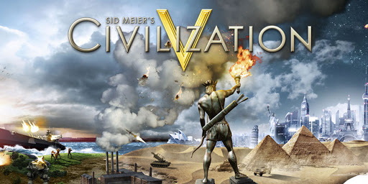
Fig 3.3(civilization)
Educators used Civilization to show students how events occurred during historical events. This was effective as Civilization included accurate historical events and characters. This motivated students to learn as they became more interested by using this visual learning tool. This was especially beneficial to visual learners.
Civilization allowed users to interact with different historical characters. This gave them the freedom to change historical events. This was stimulating for students as they were not constrained by the video game. Civilization ensured that every interaction was different by using a variable feedback system. The variable feedback system would react to what the user would do. Civilization was also useful for students to learn about politics and economics as they had to manage their own civilizations.

3.Minecraftedu (2013)
MinecraftEdu is an open-ended and modifiable educational video game. It was designed to support educators in teaching and students in basic programming.
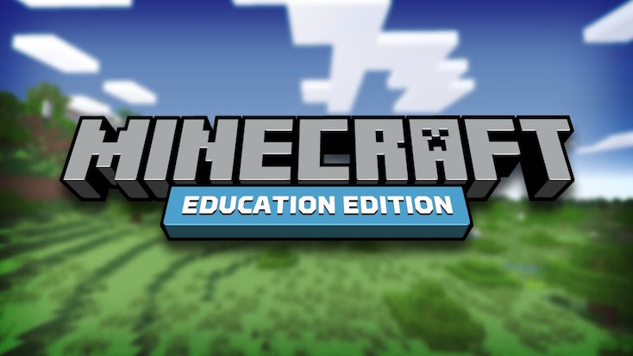
Fig 3.4(Minecraft)
MinecraftEdu’s educational content was whatsoever educators wanted to build. This could be anything from basic programming to science. This meant educators were recreating historical landmarks for history lessons or creating particles to show students how solids turn to liquid or gas. Other than teaching what educators created, MinecraftEdu also taught users about CAD (Computer Aided Design). Cody Sumter (2012) stated that Notch (creator of Minecraft) had not just built a video game, but he had tricked 40 million people into learning to use a CAD program. It did this by letting players build structures and print those using 3D printers, which is very similar to using a CAD program. This signified that whoever used MinecraftEdu would also be learning about CAD without them knowing it.
MinecraftEdu taught educational content effectively as it gave freedom to educators to create any content. The content was used to support them in their lessons. This made it more interesting for students to learn. This indicated that MinecraftEdu could be used to teach any educational principles because of its lack of constraints.
4.Simcity (2013)
SimCity is a simulation game where users found and develop a city. Although SimCity was designed not as an educational video game, it has been found beneficial by educators to use as a learning aid during lessons. Educators use SimCity as a visual aid to what might happen in cities when nuclear power plants or prisons are built. Students could also play SimCity to learn educational principles.

In SimCity, users would learn about various aspects of building and running a city. This led to learning educational principles such as business, economics and mathematics. SimCity taught these educational principles by its main goal, which was to keep the city’s citizens happy whilst keeping a stable budget. Users could increase their budget by a numerous different ways, such as by increasing taxes, legalizing gambling or building prisons. However, this could lead to citizens being unhappy depending on what the user builds. This meant users had to manage what assets to build to maximize their budgets whilst keeping its citizens happy.
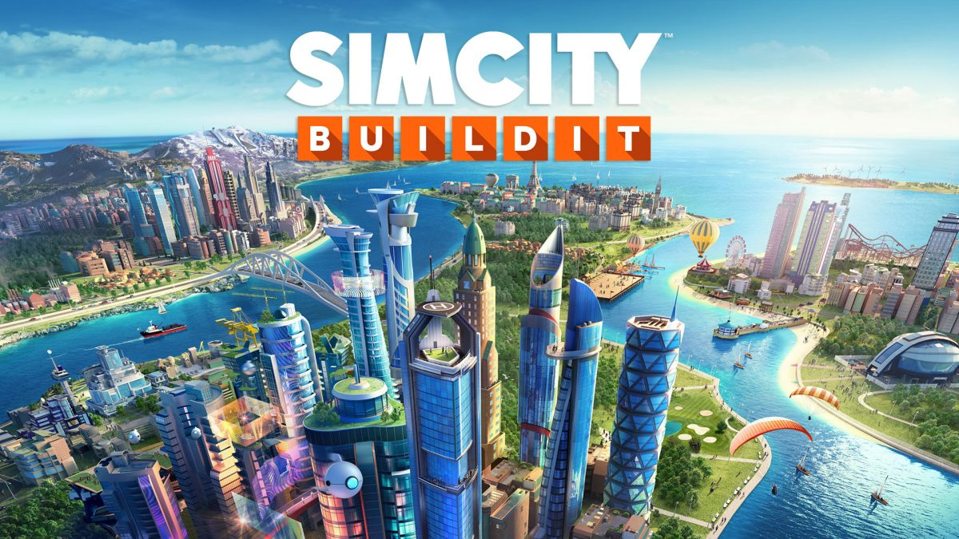
Fig 3.5(Simcity)
SimCity taught users on how to run a city. This led to users learning about different educational principles. Users would use the educational principles they had learned to solve challenges. The challenges would always differ because of the variable feedback system. The feedback system reacted to what the user did and provided them with unique challenges. This led to users being motivated as they wanted to complete the challenges. This meant that they were not aware that they were learning. Examples of such challenges are nuclear meltdowns, forest fires and alien invasions. Users had to manage their budget during these challenges and decide on what to build to avert the crisis and have a stable budget during the challenge.

3.4 CODING
Following the design stage was the coding stage, which was where the video game was coded and developed. The first phase of the coding was to find suitable software to develop the video game. To find the most suitable software, research was conducted on several different games developing software. The software had to meet certain requirements in order for it to aid in the development of the video game and achieve aims and objectives of the project. The research on the software can be seen in the justification of tools section in 3.4.1.

After the research, RPG Maker VX Ace was found the most suitable software as it was well-matched to the initial game design of the video game. RPG Maker also aided in achieving an aim, which was to develop knowledge in a scripting language. It did this as it included RGSS (Ruby Game Scripting System), which was a scripting language that was used to code the video game structure.

The next phase was to code the video game. The coding was done primarily through a GUI (Graphical User Interface). To implement the mathematical educational principles in the video game, RGSS was used as these functions did not exist in the software. Example of the RGSS coding can be seen in appendix C.

During the coding, the video game was tested several times to ensure that it was working how it was intended. After coding was completed for the video game, more testing was occurred. The testing and results can be seen in section in 3.5.

3.5 TESTING
After the coding was the testing stage. This was where the video game was tested. The testing ensured that the video game worked as intended and aided in answering the academic question. There were three different tests done on the video game. They were system testing, usability testing and beta testing. All the tests, methods and results are recorded in the following three sections.

3.5.1 SYSTEM TEST
The first test was a system test. The system test was an alpha test which was done following the video game development. This test checked whether all the functions of the video game worked as intended. This was done by trying every possible scenario during installation and playing. This test was important to the project as it ensured that there were no bugs or errors in the video game.

The method of testing was done by creating a table with a list of all possible scenarios that can happen at any stage in the video game. Every scenario was then broken down with all possible inputs that could occur. Expected results were recorded first on what should happen from all the possible inputs. The test was then conducted and the results were recorded in an actual test result section. If the actual test results did not match the expected results, it meant there was an error in the video game. This was recorded and the error would be fixed. After fixing the error, that element of the video game was tested again. After every possible scenario was tested and all test results passed, the test was finished.

Most of the results in the system test were accurate as they worked as intended. There were two errors found. The first error found was a small bug which did not allow the user to click on certain signs during the video game. This had to be fixed as the signs were meant to help players know where to go next. The second error found in the video game was that it did not accept correct answers during the mathematical aspect of the video game. This was important to correct as this aspect was vital for players, as they could not continue playing the video game unless they inputted the correct answer. After both errors were fixed, all the results were recorded in the table. The results can be seen in appendix D.
This testing method was the most suitable for the video game as it allowed easy recording of all the results. This method also ensured that every possible aspect of the video game was tested to the fullest extent. An alternative testing method was to allow users to play the video game and record any bugs or errors. The list of bugs and errors would then be fixed. This was not suitable as it was time consuming and users might not test all possible scenarios to the fullest. This would lead to certain bugs or errors still being in the video game.

3.5.2 USEABILITY TEST
The second test was a usability test. This was an alpha which was conducted after the system test. This test evaluated the HCI (Human-Computer Interaction) of the video game. This would identify which aspects of the video game work well and which could be improved. This test was important to the project as it stated how effective the video game was and where it lacked.

The method of testing was done by evaluating the video game against ten game heuristics created by David Pinelle et al. (2008). David stated that these heuristics will test all HCI aspects of the video game. The video game was evaluated against all ten statements. The evaluations were recorded in a table and the results can be seen in appendix E. The results from this test gave a better understanding on what elements of the video game were effective and what elements could be improved upon. The results of this test were used in the critical evaluation section about the video game. These results also helped in achieving the objective of identifying video game development approaches suitable for modelling educational games.

The testing method of the usability test was suitable as it allowed investigating all aspects of HCI of the video game. Using David’s list of game heuristic was beneficial as it was created from 100 different game reviews. From those reviews, he made a list of all game design aspects that were reviewed the most and used the ten most mentioned aspects to make the game heuristics. This allowed the video game to be thoroughly tested on all HCI aspects. An alternative testing method considered was to conduct the test using players. However, some players who would test the video game could lack the knowledge about HCI aspects and video games. This would lead to inaccurate results. The alternative testing method would also be time consuming. Because of these reasons, the alternative testing method was not used.

3.5.3 BETA TEST
The last test was a beta test. This test consisted of two parts. The first part of the test was a short quiz, which users took before and after playing the video game. The quiz showed whether users had learned any educational principles or not. The second part of the test was a questionnaire, which the user took after playing the video game. The questionnaire showed how users felt about the video game after playing. Both these tests were important to the project as the results aided in answering the academic question. Both parts of the beta test were done on twenty final-year university students. The test was not done on the video game’s primary users, which were primary school children, due to time constraints and health and safety risks.

The method of testing for the first part of the beta test was conducted by giving the user the quiz before playing the video game. The quiz consisted of eight questions, which were based on the educational content that was implemented in the video game. Upon the completion of the quiz, the user would play the video game. After finishing the video game, the user would undertake the same quiz again. Once the user finished the quiz, they would commence the second part of the beta test which was the questionnaire. The method of testing for the second part of the beta test was that the user would answer the questionnaire after playing the video game. The questionnaire consisted of eight questions, which were about their views on the video game. After the eight questions, there were was a section where the user could add any additional information.

The results of the quiz indicated that users had learned educational principles after playing the video game. Table 3.1 displays the quiz results which showed that users had answered more questions correctly after playing the video game. All of the questions achieved higher correct answers after playing the video game. This meant that the video game taught educational principles to whoever was playing it. The actual quiz and individual user quiz results can be seen in appendix F.

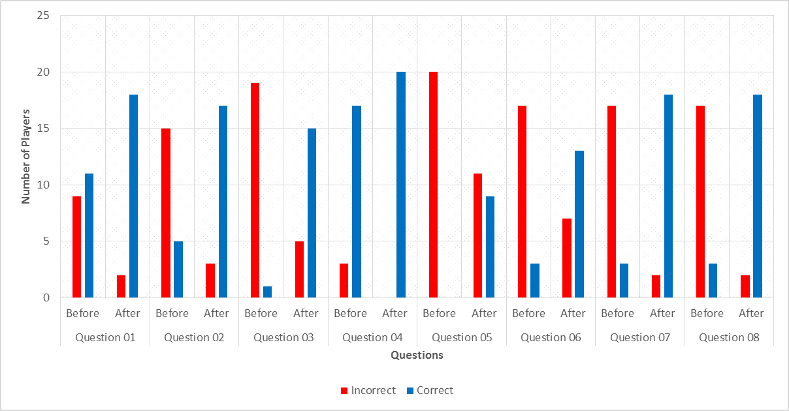
Fig 3.6 (Quiz results of twenty university students)
The results of the questionnaire indicated favorable views about the video game, where users stated that they enjoyed playing the game. Table 3.2 displays the questionnaire results which showed that 85% of users were not aware that they were learning. However, some users did state that they were aware that they were learning. One user, who stated that they felt like they were learning, specified in the questionnaire that they do not enjoy RPGs. As the user did not enjoy playing the game could be the reason that they were aware that they were learning. Another user stated that they felt like they were learning as they already knew what occurred during the historical event that the video game was based upon. As they knew what was going to happen could be the reason that they were aware that they were learning. Primary school children would not feel like they are learning as they would still be learning about the historical event the video game is based upon. The actual questionnaire and individual questionnaire responses from the user can be seen in appendix G.


Fig 3.7 (Questionnaire results of twenty university students)
There was a high probability that users would already know about the educational principles in the video game as the beta test was conducted on final-year university students. If the beta test was conducted on its primary user, they would have not known about the educational content as they would have not learnt these educational principles yet. The results of the quiz could not be accurately extrapolated to primary school children as they all have different learning styles compared to university students. The most accurate prediction that was made from the quiz results were that primary school children would learn after playing the video game, but they would not get as high marks as the university students. The questionnaire results were extrapolated to primary school children. This was as university students have a greater understanding of when learning is involved, they would be aware when a video game was teaching them educational principles. But as most university students that played the video game were not aware that they were learning means that most, if not all, primary school children will not be aware that they are learning whilst playing the video game. Using these results, the academic question can be answered accurately.

The testing method used was the most suitable method for the beta test. The questionnaire was suitable as it gave users three options to answer the questions. This allowed users to express their opinion and give accurate results. The quiz was suitable as users could not guess the answers. This meant that the quiz gave accurate results of how much a user knew and how much they learned. Alternative testing methods were considered. An alternative testing method considered for the questionnaire was to give users open questions. This would have allowed users to input any answer for the questions. This method was found unsuitable as answers could have been varied as users might not have understood the questions. This would have led to inaccurate results. An alternative testing method considered for the quiz was a multiple choice quiz. This method was found not suitable as users could have guessed the answers and gotten them correct. This would have given inaccurate results which would have led to being unable to answering the academic question effectively.

3.6 IMPLEMENTATION
The last stage of the development cycle was the implementation stage. In this stage the video game was implemented so that it can be played by users. The first phase of implementation was to create an executable file. The executable file would be used to start the video game. The file was placed in a zip folder with all the game assets. This allowed the game to be started and played without the need of any additional software.

The next phase of the implementation was to create a user manual. The user manual will benefit the users as it included an overview, hardware requirements and how to install and start the video game. The user manual was written with the main users in mind, which were primary school children. This meant that no complex words and acronyms were used. To ensure that the user manual was easily accessible for users, it was included in the zip folder.

The implementation followed the design of the video game as RPG elements had been put in the user manual. This included designs and pictures of the video game. This was to ensure that the user manual was interesting for primary school children. The icons used in the video game also followed the initial designs by having RPG elements such as castles. This ensured the implementation was of a professional quality.
CHAPTER 4
RESULTS,METHODOLOGY AND DESIGN

4.1 DESIGN
The design stage was where the video game was designed to meet the requirements set out in the requirements specification stage. The design was used to code and develop the video game. The first phase of the design stage was to conduct background research. The background research consisted of evaluating modern video games that taught educational principles. This gave a greater understanding on how educational principles are implemented into video games. The background research can be seen in section 3.3.1.

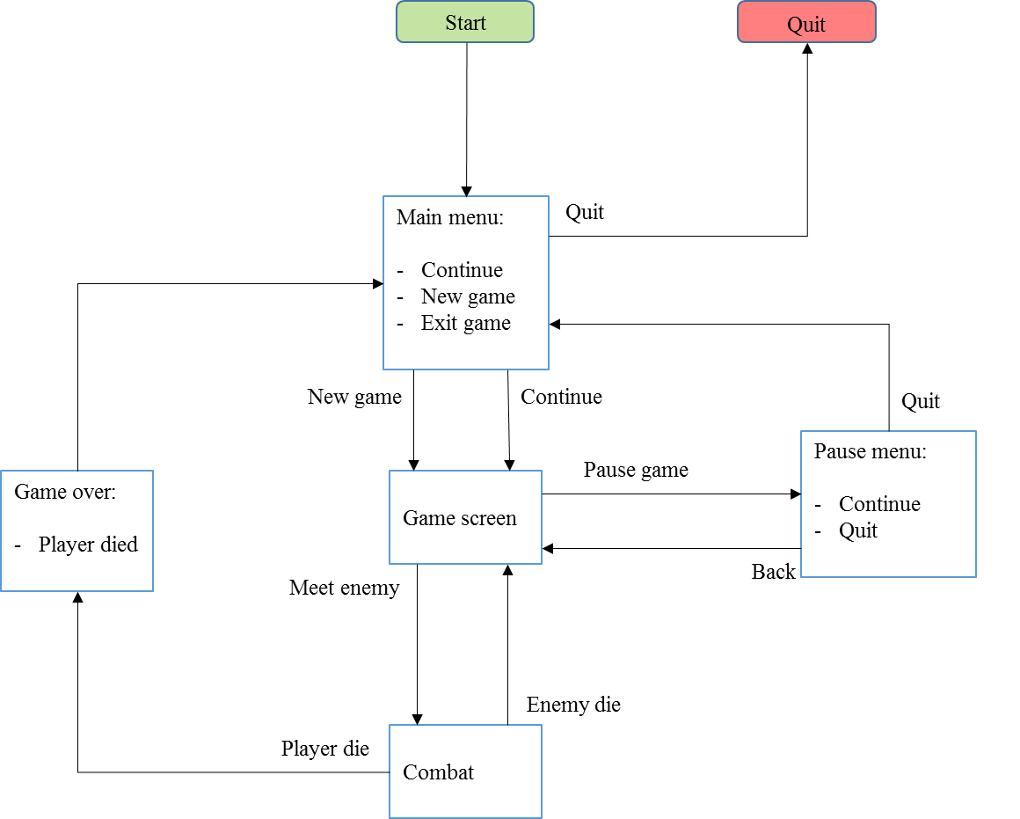

Fig 4.1(Initial flow diagram)

A list of criteria was derived after conducting the background research. The list contained five elements of what made modern educational video games effective. The five elements in the list were:

- Educational video games should be short so that users could pick up and play them when they wish to.
- Educational video games should include a variable feedback system that reacts to user inputs.
- Educational video games should have one main goal which the user intends to achieve.
- Educational video games should have additional optional quests or challenges which users should complete by using the educational content they learned from playing the video game.
- Educational video games should have an open world so that users do not feel restricted on what they could do.

This list was taken into consideration when the video game was designed. This was to aid in creating an effective educational video game. By completing the background research led to achieving the aim of investigating educational video games. This aim was important to the project as it gave knowledge on what made an effective educational video game.
The historical event chosen was the Battle of Hastings. This meant that the video game would have a strong storyline with combat. This would lead to students being more motivated to keep playing. This point is backed up by research conducted by Matthew Horsfall and Andreas Oikonomou (2011), who stated that players enjoy RPG which favors strong storylines, character development and combat.
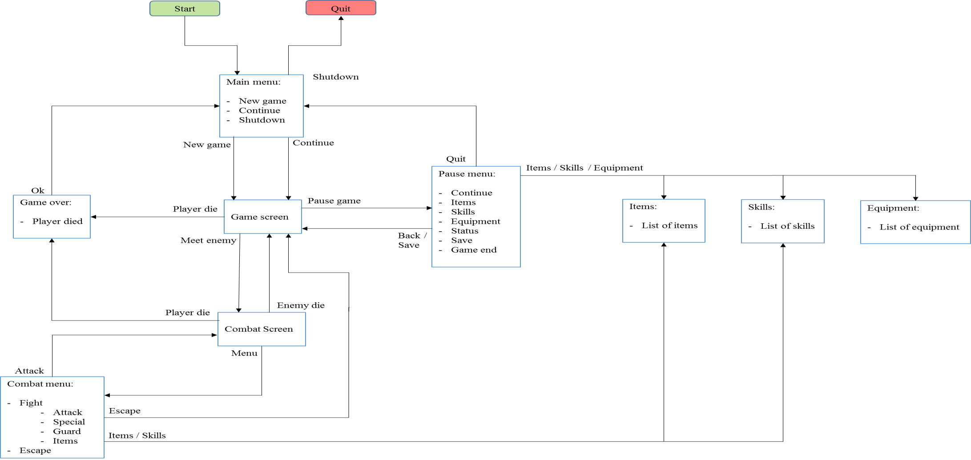
Fig 4.2( Final flow diagram)

The following aspect of the design stage was to create a flow diagram. Eugenio J. Marchiori et al. (2012) stated that a flow diagram provides a high-level overview of a game which allows for the identification and definition of key elements and concepts.
The initial flow diagram created was a plan on what would be in the video game. During the design stage the flow diagram was expanded as new features were added to the video game. The initial flow diagram and the final flow diagram created for the video game can be seen in appendix A.

The next aspect of the design stage was the actual design of the video game. To ensure the design was going to be suitable, a design methodology was going to be followed. The design methodology followed in this project was the one researched during the literature review. The first aspect of the design methodology was the concept. The concept was going to be based on educational content. To choose suitable educational content for primary school children, research was undertaken on what they were learning between the ages of 7-11. The research involved going on various KS2 (Key Stage 2) websites, which included BBC and Crickweb. After conducting the research, it was decided that the video game would be based on a historical event that primary school children were learning. This was chosen so that the educational content would become the game’s narrative. This ensured that the video game would be motivational for students. The historical event chosen was the Battle of Hastings. This meant that the video game would have a strong storyline with combat. This would lead to students being more motivated to keep playing. This point is backed up by research conducted by Matthew Horsfall and Andreas Oikonomou (2011), who stated that players enjoy RPG which favors strong storylines, character development and combat. Very few players preferred gameplay that focused on in game items. This research was backed up Michail Giannakos (2012), who stated that:
“Research has shown that a story-based math video game has captivated the interest of students and it has been beneficial in the improvements of their performance in an assessment test. Most notably, the improvements were higher for students who used to have poor performance in mathematics.”

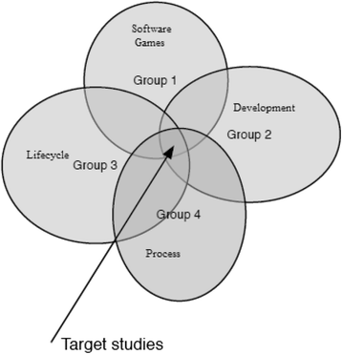
Fig 4.3(Model Study)

This indicated that a story based educational video games was more motivational for students than general educational video games. If students were more motivated, they will want to keep playing the video game which will lead to them learning more educational concepts.

After choosing the concept of the video game, it was time to choose a suitable genre. To ensure that the video game had an open world, the RPG genre was chosen. Mary Jo Dondlinger (2007) stated that the most suitable genre was RPG as it contains elements of various different genres. This indicated that primary school children that do not enjoy RPG could at least enjoy one aspect of the video game that was based on different genres.

The next aspect of the design methodology was to create the rules and challenges of the video game. The challenges of the video game were based on educational principles. The first challenge was based on geography. Directions given to the players were in cardinal points. This ensured that students know where the four points on a compass are. This challenge also fit in with the narrative of the video game as during those times directions were given in this manner. The second set of challenges was mathematical questions. The questions were based on simple addition, subtraction, division and multiplication. These questions were asked with elements of the storyline. This ensured that the math questions complemented with the storyline. This meant that the learning outcomes of the video game were:
- Cardinal direction (Geography)
- Addition, subtraction, division and multiplication (Mathematics)
- Battle of Hastings (History)

The last aspect of the design methodology was the storyline and the actual design of the video game. The storyline was created to indicate where the player would go, where they would encounter the challenges and how the video game would end. A storyboard was used to create the storyline of the video game. The storyboard can be seen in appendix B. The design of the video game had to follow the storyboard and educational content, which was set in the year 1066. This meant that the video game could not contain any elements designed after 1066, such as cars, airplanes and guns. After completing the design methodology, the video game was coded and developed, which was done in section.
4.2 RESULTS
- It is the game development tool which has got whopping community of asset and the plugin developers and you will be able to get the reasonable and free content available.
- Unity provides the class apart editing tools for the game developers and this can also be extended with the plugins.
- It also supports the assorted range of asset formats which is meant for conversion automatically to maximum formats for the target platform too.
- It also supports the elite range of operating systems and platforms, like the mobile, desktop, and the gaming consoles.
- This game development tool is available at the free license and have got class features.
4.3 METHODOLOGY
It is likely that as the field matures, analysis of games will segment, as we are already seeing to some degree with new calls for analysis of roleplaying games, as well as explorations of games in the "survival-horror" genre. But we believe that the method outlined above is broad enough to encompass analyses of games from different genres, while also allowing the researcher enough flexibility to account for the specifics of the game and genre under the microscope. Yet we fully expect that this methodology will be modified and, perhaps over time, will become more specialized for various genres in order to help understand their particular insights and elements.But for now this methodological toolkit-interaction mapping, object inventory, interface study and logging gameplay-is offered as a starting point for researchers interested in studying digital games, as a way to make the research thorough, without losing those aspects of games-play and emergence-that make them the dynamic artefacts of culture that they are.

Step 1: High Concept
The first major step in how to develop a game is the high concept. This is a general idea. It’s a very brief description where you try to distill your ideas down to a few sentences

Step 2: Pitch
This is the big one. You pitch your idea in a summarized form to best communicate ideas and their goals. It’s also a time to promote why it would be a prudent idea to develop financially and commercially.

Step 3: Concept
Further along, this is the lovechild between the high concept and pitch. This is where you outline and describe all of the aspects of the game. We’re talking story, demographics, risk analysis and a boatload of further information.

Step 4: Game Design Document
This document includes aspects tied to actual gameplay and may include prototypical aspects of your project.

Step 5: Prototype
This is where you and your team can shine early on. Building the prototype will allow you to develop the methods in which you’ll fully execute your idea. It’s a good way to build a proof of concept, adapting your goals into a more tangible form.

Step 6: Production
- Design
- Level Creation
- Programming
This is when the ball starts to roll. Things like sound and early graphical assets begin to be implemented. The game is lifted off of the ground and finally starts to take shape. This is where programming comes into the game development process
It has all the details you need:
- Plot points
- Story details
- Character biographies and aesthetics
- Level designs and objectives
- Game mechanics and core gameplay concepts
- Themes and aesthetics for the game.

CHAPTER 5

SOFTWARE REQUIREMENTS

5.1 JUSTIFICATION OF TOOLS
There were numerous software found that could have been used to code the video game. To find the most suitable software for the video game, the most common game developing software were researched and evaluated.

1.GameMaker
The first software researched was GameMaker. GameMaker is used generally to create 2D games which could be exported to multiple platforms.

GameMaker could have been beneficial with the coding of the video game as it had a simple drag-and-drop interface which allowed for fast prototyping. Complex functions had to be coded using GML (GameMaker Language). This was the scripting language for GameMaker, which was based on the C programming language. This meant GameMaker would have been suitable to achieve the aim of developing knowledge in a scripting language.

A limitation of GameMaker was that it did not support the initial video game design. This was due to the software being targeted for 2D games, which the initial design of the video game was not.
Overall, GameMaker would have been the most appropriate software for the coding if the development cycle was going to be rapid prototyping. This was because it had a relatively simple user interface which allowed for quick prototyping. However, the development cycle for the video game was a waterfall model so there was no need for rapid prototyping.

2.RPG Maker
The following software researched for coding the video game was RPG Maker. The current version at the time of this project was RPG Maker VX Ace, which is used to develop 2D RPGs (Role-Playing Games).

A benefit of using RPG Maker was that the software had basic technical aspects builtin, such as the user interface and character controls. This was suitable for the video game as it meant fewer aspects to code. RPG Maker also used a scripting language, known as RGSS (Ruby Game Scripting System), which would have aided in achieving the aim. Another benefit of RPG Maker was that it has character generators. This meant there was less design work to do if this software was chosen.

A limitation of RPG Maker was that it was primarily designed for RPGs. However, this did not affect the video game, as the initial design of the video game was a RPG.
Overall, RPG Maker seemed so far the most suitable software to code the video game as it suited the initial designs. RPG Maker would also help in achieving the aim of developing knowledge in a scripting language.

3.Unity
The next software that was researched was Unity, which is a development suite used to make 2D and 3D games.
A benefit of Unity was that it would aid in achieving the aim of developing knowledge in a scripting language. This was because Unity used C# and C++. Unity also contained every tool needed to create video games of any type and genre. This included characters and locations. Unity also matched the initial video game designs. This meant Unity was suitable to code the video game.
However, there were some limitations of using Unity to code the video game. The first limitation was that there were not many basic controls built-in the software. This meant that all the basic controls of the video game would need to be created. This included the user interface and character controls. This would have led to extended development times for the video game. Another limitation of Unity was that it was targeted for advanced users who have extensive knowledge of C# or C++. As there was no prior knowledge of either programming languages, coding would have been delayed while the programming languages were being learned.
Overall, Unity did not seem suitable software to code the video game. This was mainly due to the complexity of the software. Other software, such as RPG Maker and GameMaker, provide more features which were relevant to the initial video game design. There was also less prior knowledge needed to use other software.

4.Unreal Development Kit
The last software researched for coding the video game was the Unreal Development Kit, which is a development suite used to make 2D and 3D games. Unreal had similar features as Unity.
A benefit of using the Unreal Development Kit would be that it included all the tools needed to develop the video game. This includes tools to create characters, locations and user interfaces. Unreal also used the C++ programming language to code video games, which would have aided in achieving aims and objectives.
A limitation of the Unreal Development Kit was that it was designed for professionals.
Because there was no prior knowledge of Unreal, this would have led to extended development time for the video game. Another limitation of Unreal was because of the vast amount of tools, it was designed to be used by teams. This meant that Unreal was unsuitable to code the video game as it was going to be coded and developed by only one person.
Overall, the Unreal Development Kit had similar benefits and limitations to Unity. Because of this, Unreal did not seem suitable to use for the project for similar reasons as Unity. Other software seemed far more suitable for the coding of the video game.

CHAPTER 6
CONCLUSION,FUTURE SCOPE AND APPENDIX

6.1 CONCLUSION
This project’s aim was to answer the academic question. The academic question was:
Can video games teach basic educational principles to primary school children without them being aware that they are learning?
Using the video game created and the results from the tests, it can be stated that video games can teach basic educational principles to primary school children without them being aware that they are learning. The video game had three main learning outcomes. They were to teach players three main educational principles from different subject areas, which were:
- Cardinal direction (Geography)
- Addition, subtraction, division and multiplication (Mathematics)
- Battle of Hastings (History)
The beta test results showed conclusively that players had learned about the battle of Hastings. By players completing the video game, it can be stated that they learned about geography and mathematics. If they did not, they would have not been able to complete the video game.

The project also had four aims, all of them which were achieved. The aims of the project were important as they identified what the project was trying to achieve. They aims were:
- To evaluate the use of video games as educational tools.
- Investigate educational video games.
- Evaluate the video game development process.
- Develop knowledge in a scripting language.

- Complete a literature survey and literature review on how video games are being used as educational tools.
- Identify and evaluate game design of existing educational video games.
- Develop a suitable video game.
- Evaluate the effectiveness of the video game using appropriate tests.
- Identify video game development approaches suitable for modelling educational video games.
- To learn and develop skills in a scripting language dependent on the tools used to develop the video game.
- Complete final report.

6.2 FUTURE SCOPE
The gaming industry has an array of career choices to offer. It makes up for a large segment on the employment front too. According to statistics shared by the American Gaming Association, game industry jobs provide employment to as many as 1.7 million individuals, with the employment rate growing by 62,000 jobs (on average) every year.
The most common myth about game industry jobs is the lack of options. However, game careers are not limited to game design and game development. Here are some game industry jobs that you can take up as a profession:

Video Game Designer:

you don’t code and cannot sketch, but you have a million-dollar idea for a game that could be a breakthrough. Well, you are not in for a disappointment. The job of a video game designer is to create a blueprint of the characters and the purpose of the game.

Video Game Artist:
drink some coffee, grab your sketchbook and wake up the artist in you! Video game designers need to work around animated characters to design the game. Here’s where a video game artist’s talent comes into play. So, go ahead and draw your imagination!

Writer:
almost every video game has a background story. Take for instance the popular game, “Marvel Contest of Champions”. The dialogue depiction is a major part of the game and, of course, needs writers. Today, many games incorporate scripts to make the games look more interactive. Moreover, writers are also responsible for the manuals and the in-game menus.

Audio Programmer:

a major element, and one of the USPs of any game, is the background score. Long gone are the days when music was just part of movies and plays. In fact, the sound effects in a game have proven to be as important as the game’s visual appeal. This is where audio engineers play their part in making the gaming experience worthwhile.

Game Programmer:
to become a video game programmer, you need two things – a knack for coding and a love for video games. For your support, you will need the whole ensemble of the video game designer, writers, video game artists, audio programmer and a slew of other video game professionals. However, you will be responsible for bringing the game to life on a device.

Game Tester:
Imagine getting paid for playing games? Well, that’s what a game tester has to do - for a living - almost every day! Though it sounds merry and fun, the job of a games tester is not any easier than that of a video game designer or a game developer. Game testers have to pay attention to minute details while playing the game so that they can take notes on the user interface and glitches (in case there are any).

Professional Gamer:
though it sounds unbelievable, playing games can make you rich. With YouTube videos becoming a major source of income for many, “All play and no work” doesn’t seem like a bad idea at all. The trending “Let’s Play” videos have earned competitive gamers enough to live a comfortable life.
A video game designer and an audio programmer are most likely to not have the same set of skills that are instrumental in a game. However, their worth in the market, in terms of average salary, is estimated to be around £30,000 per annum. A video game artist’s average salary is around £40,000 per annum, while that of a game producer varies from £40,000 to £80,000 depending on the success of the game. A writer’s average income also depends on the game’s success and can go up to £150,00

APPENDIX
A.SCREENSHOTS
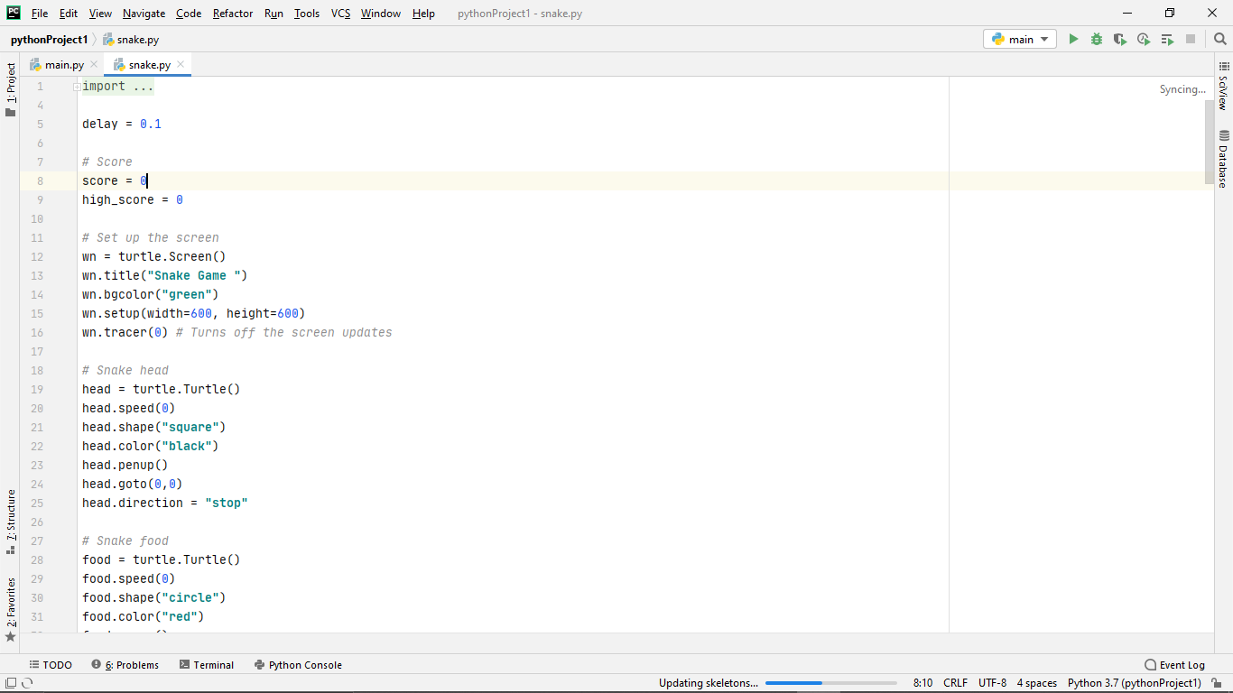
Fig 4.1(code)
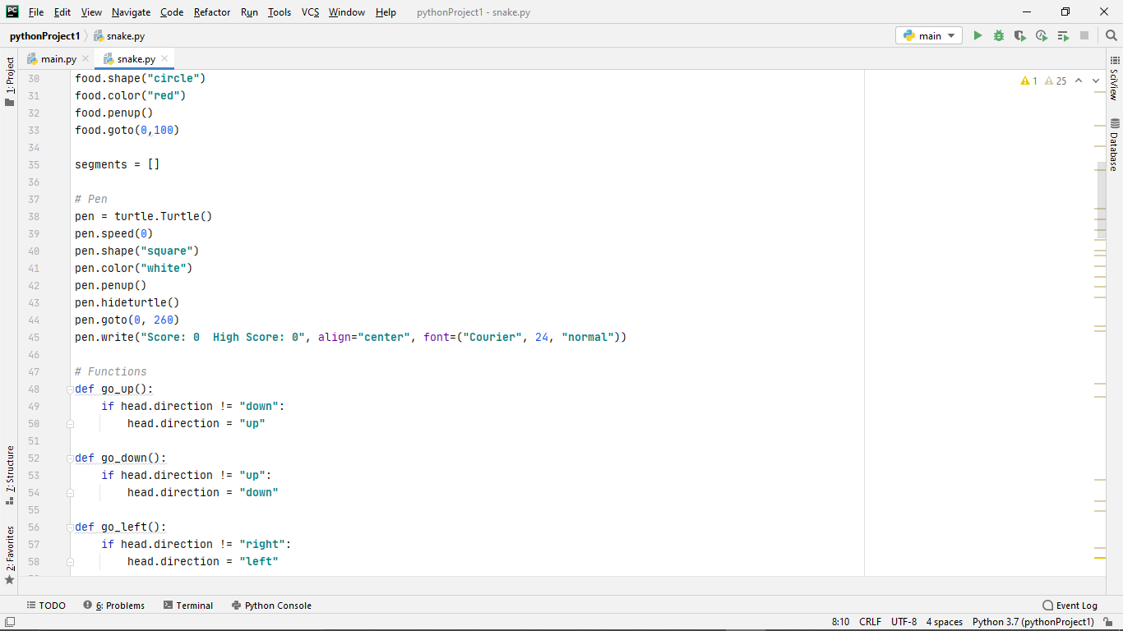
Fig 4.2(code)

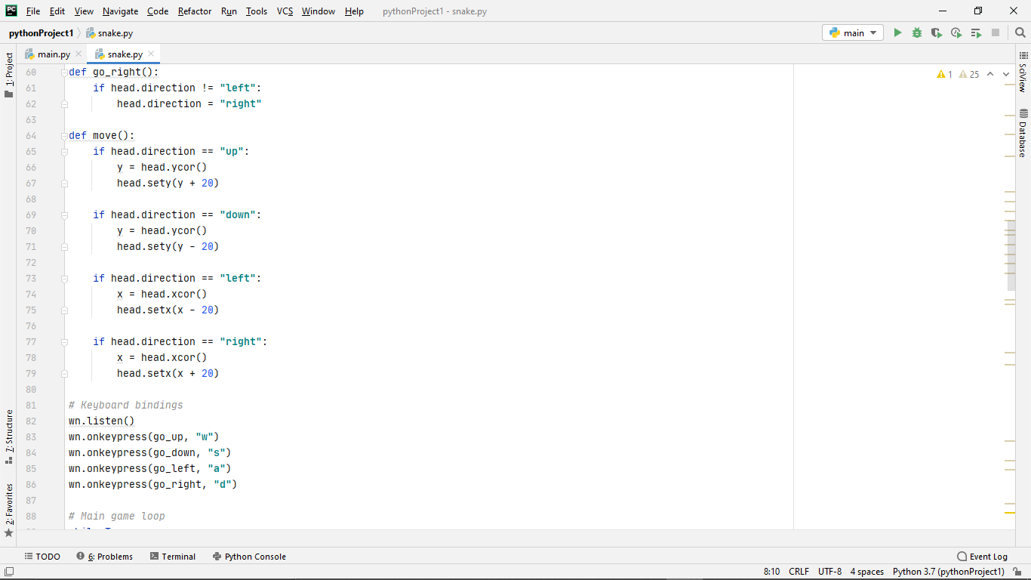
Fig 4.3(code)

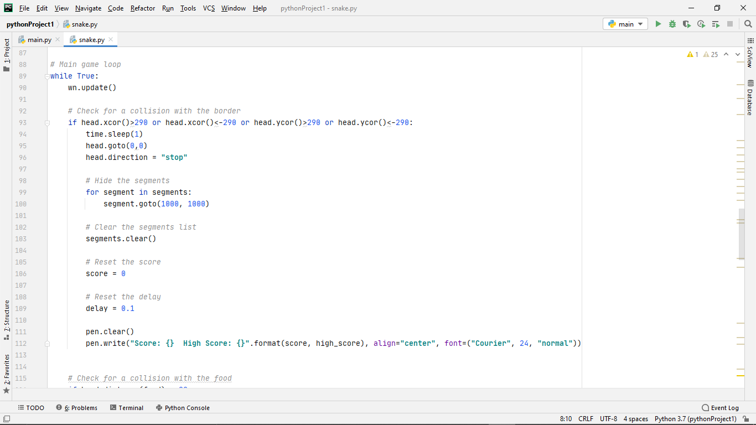
Fig 4.4(code)

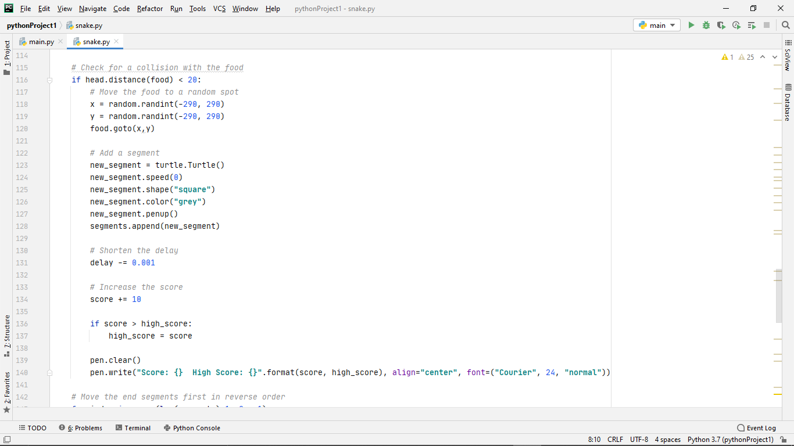
Fig 4.5(code)

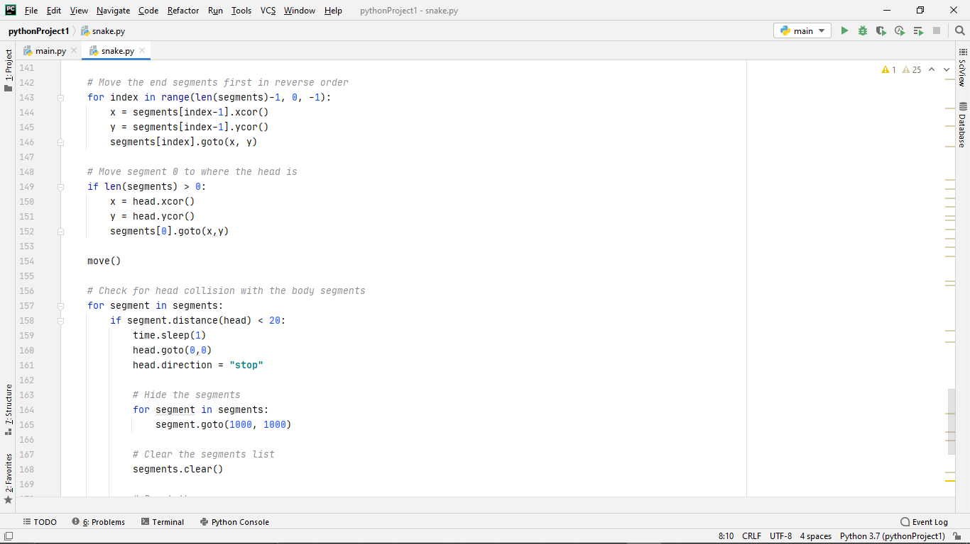
Fig 4.6(code)
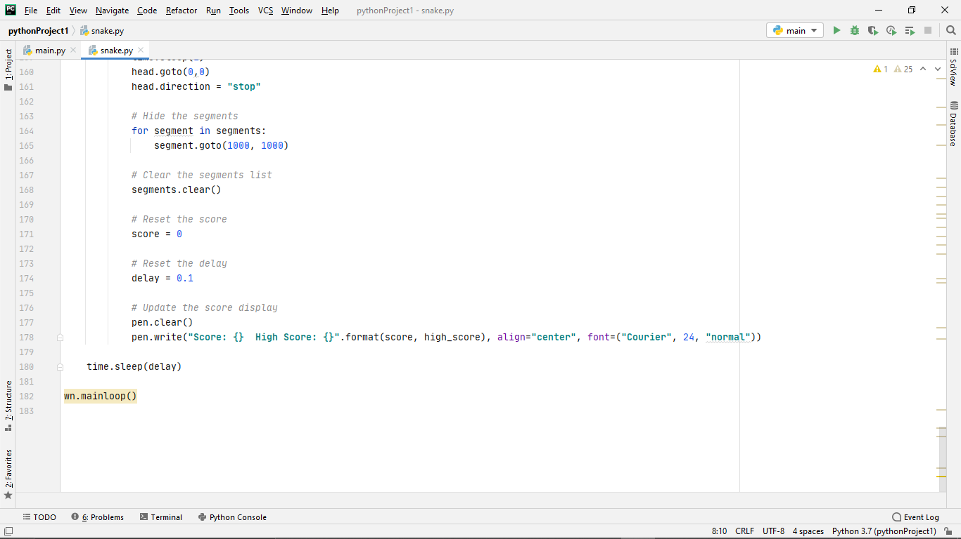
Fig 4.7(code)
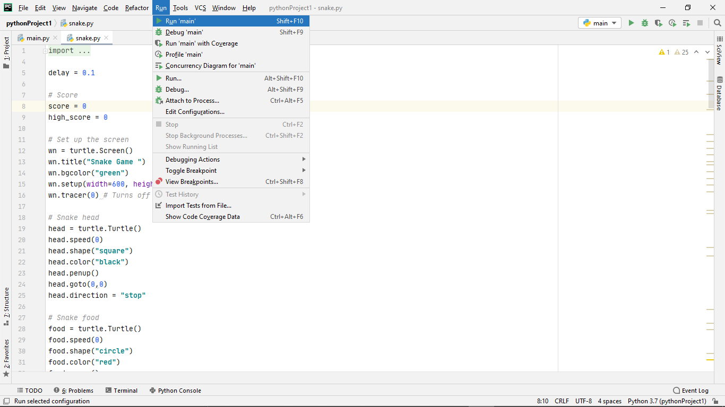
Fig 4.8(Run & compile)
The above screenshots are the are source code of the program that is developed and implemented in pycharm complier and the code is run and compiled as per the Fig4.8 and the proceeds with the following diagram below.

SERIAL MONITOR OUTPUT
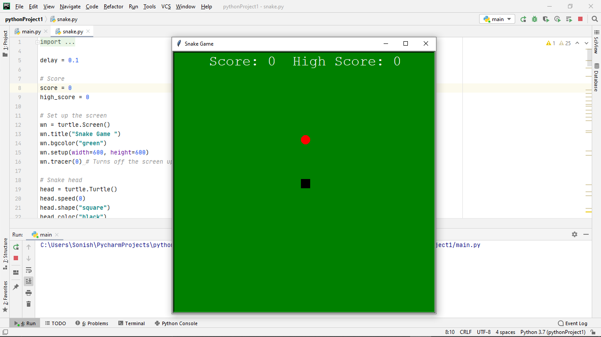
Fig4.9(Game Screen)
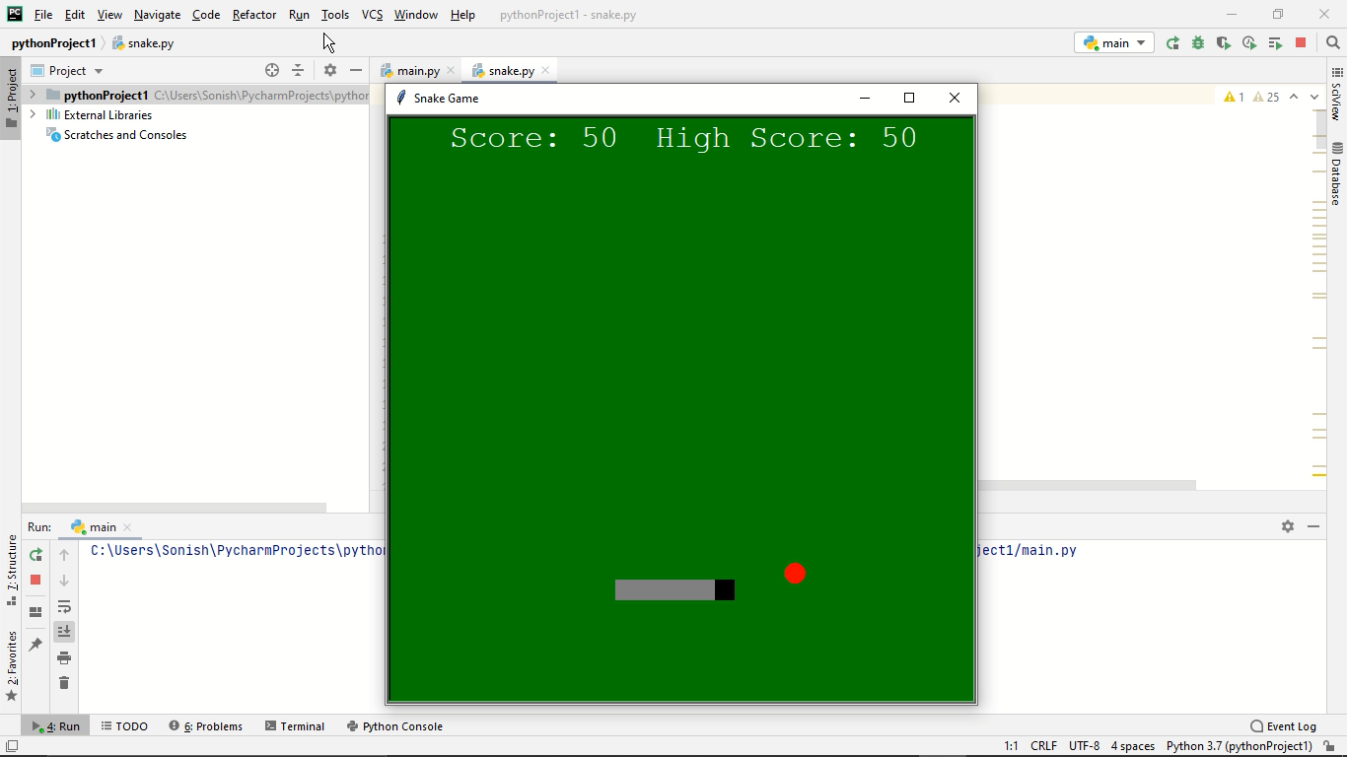
Fig 4.10(Game screeen)
Now the game screen opens up and we can start playing the game as per keyboard control for moving up,down,left and right pressw,s,a,d respectively the snake starts moving and catches the red dot and the length of the snake gradually increases and the score is noted.Such the game is set to be played in this serial monitor shown as in Fig4.10.
B.SOURCE CODE
import turtle
import time
import random

delay = 0.1

# Score
score = 0
high_score = 0

# Set up the screen
wn = turtle.Screen()
wn.title("Snake Game ")
wn.bgcolor("green")
wn.setup(width=600, height=600)
wn.tracer(0) # Turns off the screen updates

# Snake head
head = turtle.Turtle()
head.speed(0)
head.shape("square")
head.color("black")
head.penup()
head.goto(0,0)
head.direction = "stop"

# Snake food
food = turtle.Turtle()
food.speed(0)
food.shape("circle")
food.color("red")
food.penup()
food.goto(0,100)

segments = []

# Pen
pen = turtle.Turtle()
pen.speed(0)
pen.shape("square")
pen.color("white")
pen.penup()
pen.hideturtle()
pen.goto(0, 260)
pen.write("Score: 0 High Score: 0", align="center", font=("Courier", 24, "normal"))

# Functions
def go_up():
if head.direction != "down":
head.direction = "up"

def go_down():
if head.direction != "up":
head.direction = "down"

def go_left():
if head.direction != "right":
head.direction = "left"

def go_right():
if head.direction != "left":
head.direction = "right"

def move():
if head.direction == "up":
y = head.ycor()
head.sety(y + 20)

if head.direction == "down":
y = head.ycor()
head.sety(y - 20)

if head.direction == "left":
x = head.xcor()
head.setx(x - 20)

if head.direction == "right":
x = head.xcor()
head.setx(x + 20)

# Keyboard bindings
wn.listen()
wn.onkeypress(go_up, "w")
wn.onkeypress(go_down, "s")
wn.onkeypress(go_left, "a")
wn.onkeypress(go_right, "d")

# Main game loop
while True:
wn.update()

# Check for a collision with the border
if head.xcor()>290 or head.xcor()<-290 or head.ycor()>290 or head.ycor()<-290:
time.sleep(1)
head.goto(0,0)
head.direction = "stop"

# Hide the segments
for segment in segments:
segment.goto(1000, 1000)

# Clear the segments list
segments.clear()

# Reset the score
score = 0

# Reset the delay
delay = 0.1

pen.clear()
pen.write("Score: {} High Score: {}".format(score, high_score), align="center", font=("Courier", 24, "normal"))

# Check for a collision with the food
if head.distance(food) < 20:
# Move the food to a random spot
x = random.randint(-290, 290)
y = random.randint(-290, 290)
food.goto(x,y)

# Add a segment
new_segment = turtle.Turtle()
new_segment.speed(0)
new_segment.shape("square")
new_segment.color("grey")
new_segment.penup()
segments.append(new_segment)

# Shorten the delay
delay -= 0.001

# Increase the score
score += 10

if score > high_score:
high_score = score

pen.clear()
pen.write("Score: {} High Score: {}".format(score, high_score), align="center", font=("Courier", 24, "normal"))

# Move the end segments first in reverse order
for index in range(len(segments)-1, 0, -1):
x = segments[index-1].xcor()
y = segments[index-1].ycor()
segments[index].goto(x, y)

# Move segment 0 to where the head is
if len(segments) > 0:
x = head.xcor()
y = head.ycor()
segments[0].goto(x,y)

move()

# Check for head collision with the body segments
for segment in segments:
if segment.distance(head) < 20:
time.sleep(1)
head.goto(0,0)
head.direction = "stop"

# Hide the segments
for segment in segments:
segment.goto(1000, 1000)

# Clear the segments list
segments.clear()

# Reset the score
score = 0

# Reset the delay
delay = 0.1

# Update the score display
pen.clear()
pen.write("Score: {} High Score: {}".format(score, high_score), align="center", font=("Courier", 24, "normal"))

time.sleep(delay)

wn.mainloop()

REFERENCES
- Unity Game Development Essentials
- 3D Game Development with Microsoft Silverlight 3
- Releasing HTML5 Games for Windows 8
- A Theory of Fun for Game Design
- Writing for video Game Genres: From FPS to RPG
- Game Physics Pearls
- CryENGINE Game Programming with C++, C#, and Lua
- Building XNA 2.0 Games
- Computer Games and New Media Cultures
- Google SketchUp for Game Design
- Unity 4.x Game AI Programming
- Real-World Flash Game Development
- Getting Started with UDK
- Erfolgreiche Spieleentwicklung
- 3D Game Programming for Kids
- Are Video Games Harmful?
- UnrealScript Game Programming
- Learn Unity for 2D Game Development
- Social Game Design
- Holistic Game Development with Unity
- Beginning Game Art in 3DS Max 8
- Game Physics Engine Development
- Multiplayer Game Programming
- Virtual Reality: Concepts and Technologies
- Game Development for iOS with Unity3D
- iOS 7 App Development Essentials

